TO ACCESS THE TEMCO AP BLEND DETERGENT SDS SCAN THE QR CODE BELOW:

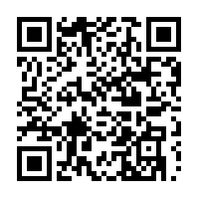

IF YOU HAVE ANY QUESTIONS OR NEED ADDITIONAL ASSISTANCE, PLEASE CONTACT US AT 800-245-1869 OR EMAIL TEMCO@WASHPARTS.COM

THANK YOU,
CAROL HAWORTH – TEMCO PRODUCT SPECIALIST
800-245-1869 | www.washparts.com |temco@washparts.com

